GOAL

QUALITY ASSURANCE AUDITS DASHBOARDS
To develop a fully automated Quality Audits dashboards as identified by the Quality team, that will cater to stakeholders and Quality Team’s analysis needs.
These dashboards should either be per Team, Group (Commercial / Technical), Zone and Global Hub Overall.

BENEFIT
Through these dashboards, QA specialist & stakeholders can better monitor the agents' quality performance, identify coaching points, create RCA as needed and for reporting purposes.
These dashboards will also allow the Quality Team to Track their completed audits.

PROJECT SCOPE
In Scope: Global Hub Teams being audited by OPEX – NAM Quality Team
Out of Scope: Global Hub Teams not being audited

Issues, Dependencies, Risks & Mitigations
In Scope: Global Hub Teams being audited by OPEX – NAM Quality Team
Out of Scope: Global Hub Teams not being audited

PROJECT TEAM MEMBER
Project Sponsor: Marj LAZO
Project Champions: Quality Specialist per Team
Project Lead: Gem Crisostomo
Project Member: Kenneth Golosinda
QA Dashboards Tableau Main Folder
QUALITY ASSURANCE AUDITS DASHBOARDS

https://tableau.schneider-electric.com/#/site/CXAnalytics/workbooks/84445/
COMPLETED DASHBOARDS 2024
Dashboard Name | Views | Link
NAM QA Dashboard | - Technical Support  - Commercial Support | NAM QA Dashboard

DATA INCLUDED: Old Forms’ Overall QA Scores Combined with New Forms’ Results
DATASOURCE REFRESH SCHEDULE: Daily every 9PM, 1AM, 6AM. Runtime 10-15mins
DATE REFERENCE: Created Date
OVERALL QA SCORE CALCULATION: Average of Overall QA Score

DASHBOARD MANUAL
QUALITY ASSURANCE AUDITS DASHBOARDS

Toggle Period – Use to toggle charts’ date axis to Daily, Weekly, Monthly, Quarterly & Yearly
Start Date & End Date – Use to Filter Audits based on Audit Created Date. *Not applicable for Summary Cards Results
Filters:
- Type of Evaluation
- Type of Interaction
- POC Country*
- Business Unit*
- Team Manager
- Agent Name
- Case Number
* If applicable in Audit Form
** Refer to Summary cards info for Filters applicable for Summary card views
You can also click on a datapoint to filter the dashboard. Click once more to un-apply filter. Not applicable to summary cards.
Link to Sharepoint List (Audit Form) – Click Image
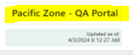
Data Refresh Info
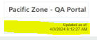
Type of Evaluation Group – This is to combine old and new form names and shorten it for better visualization.
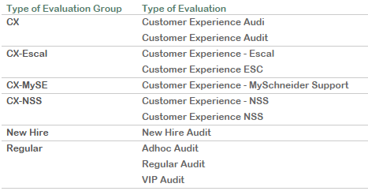
Summary Cards:
QUALITY ASSURANCE AUDITS DASHBOARDS

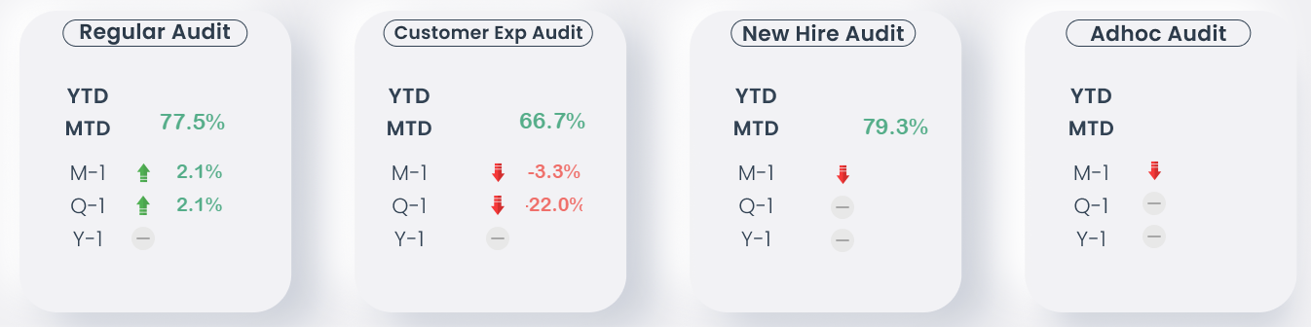

QA Score Color – Green: On Target Red: Below Target
QA Score Target – 90%
Hover to a line graph data point to see Tooltip
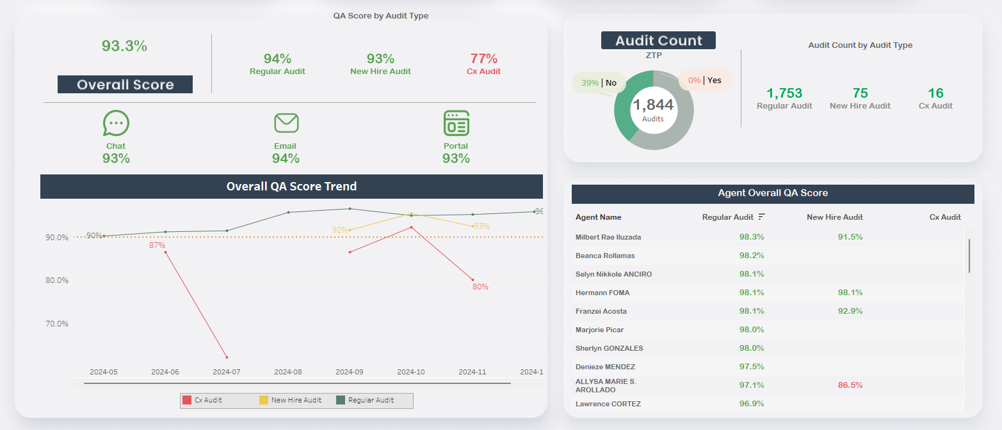

Customer Critical Score: % of Audits with Yes (Achieved) / Total Number of Audits Applicable to each Customer Critical Category
QUALITY ASSURANCE AUDITS DASHBOARDS

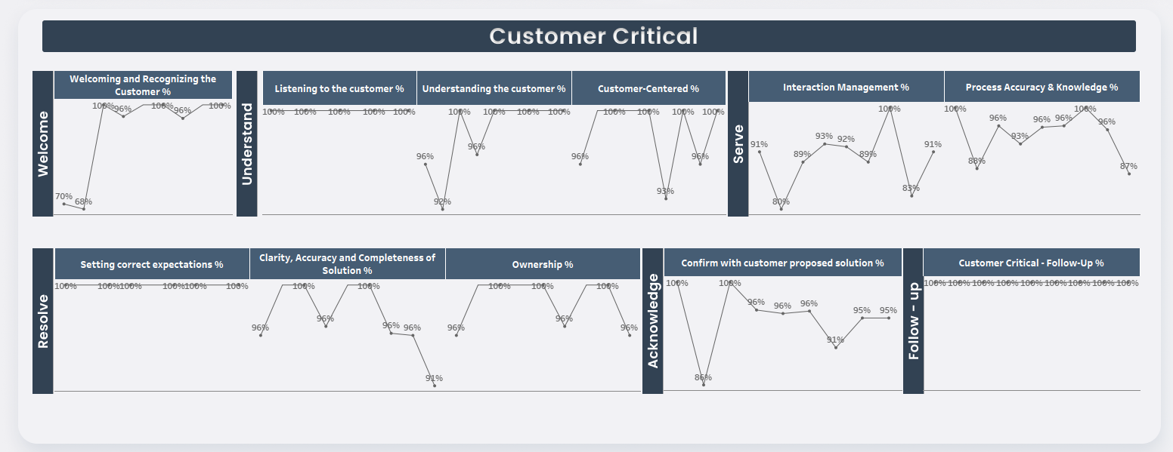
Business Critical Score: % of Audits with Yes (Achieved) / Total Number of Audits Applicable to each Customer Critical Category
Case Duplicate: Distribution of Audits with Case Duplicates
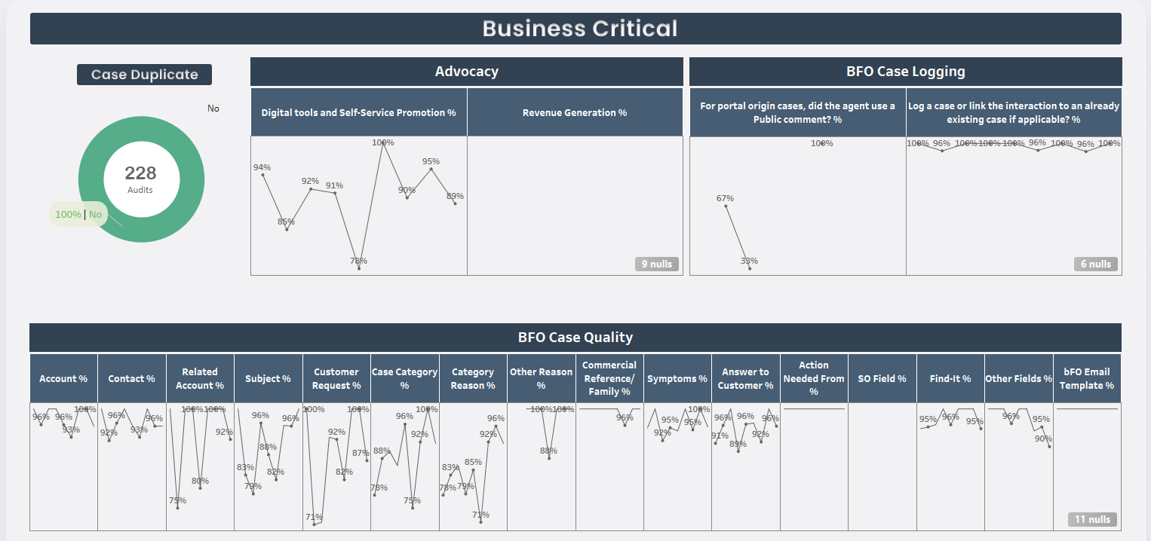

Audit Count: Volume of Audits per BU, Agent and Type of Eval. Heatmap: Darker means higher # of audits

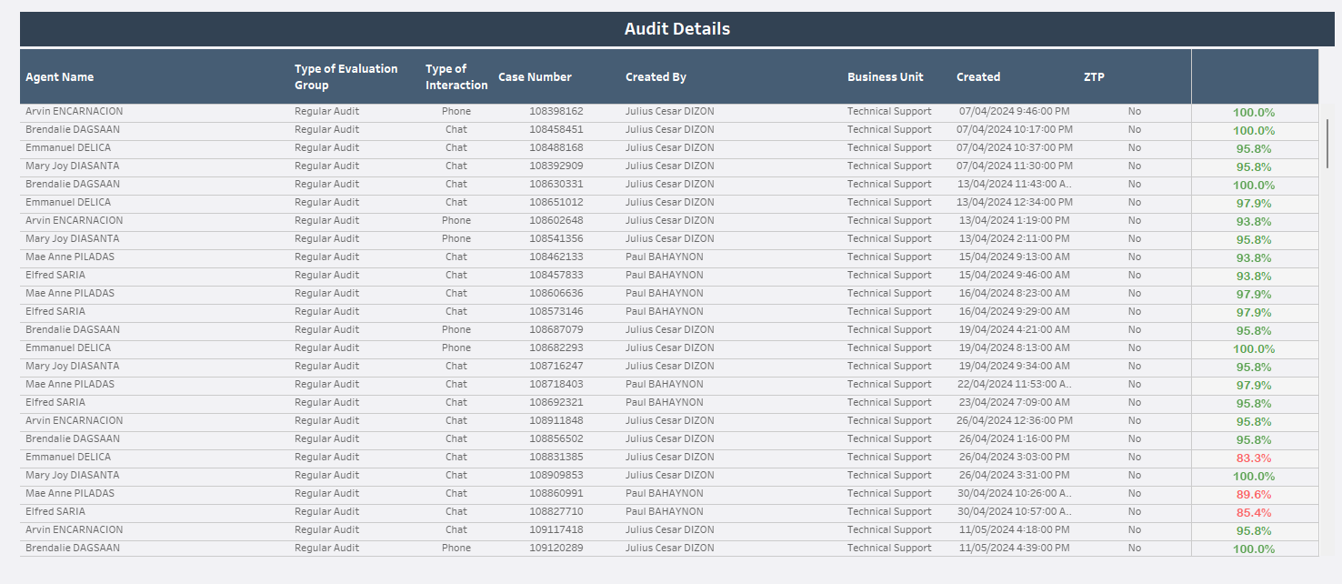
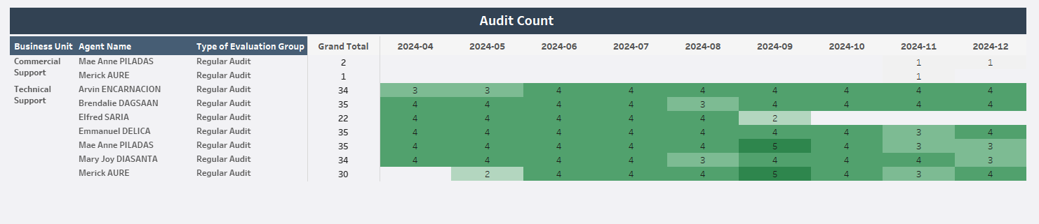

Audit Details: Shows row level data for each audit. Click on a row to show Audit ID Link to Sharepoint List
QUALITY ASSURANCE AUDITS DASHBOARDS


Click on a row to show Audit ID Link to Sharepoint List. This makes it easy to access the actual audit in the SP list.
